**Make fun with Lines**

Here in this mini project I am making a windows form application in which user can provide some inputs like- no_of_lines, angle, increment, length.

When user is clicking on Go button a pattern will be drawn inside the windows form. I created 2 panels inside the form in panel 1 all the inputs and button is there and background colour is black and in the panel 2(canvas) the pattern/shape will be drawn.

I used random function to get different colour of each line that has to be drawn.

The basic idea behind this application is every time we calculate start_x and start_y and by this, calculate end_x, end_y. After each line that has been drawn we change the value of start_x and start_y with end_x and end_y respectively.

So, after varying some angles and no_of_lines, we can get some cool shapes.

After changing the input from the user, the following shapes can be get:

**If Lines = 100, angle = 160, Length = 5, Increment = 7**

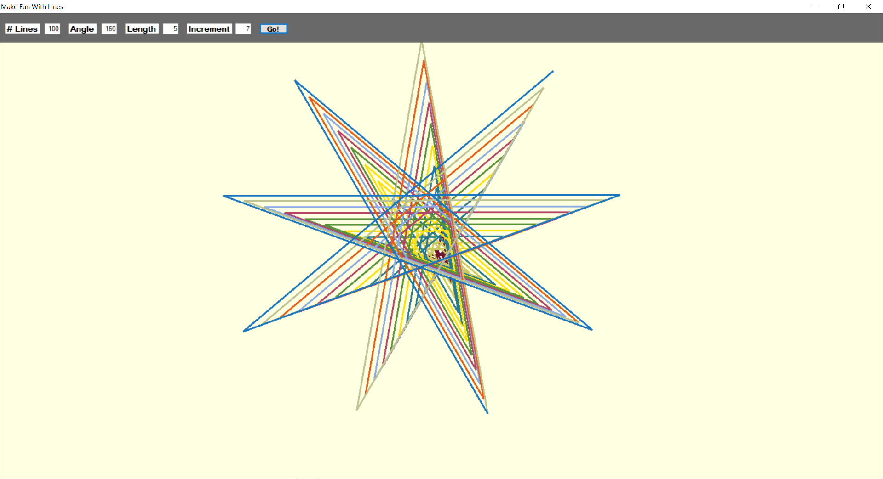

**If Lines = 100, angle = 30, Length = 5, Increment = 2**

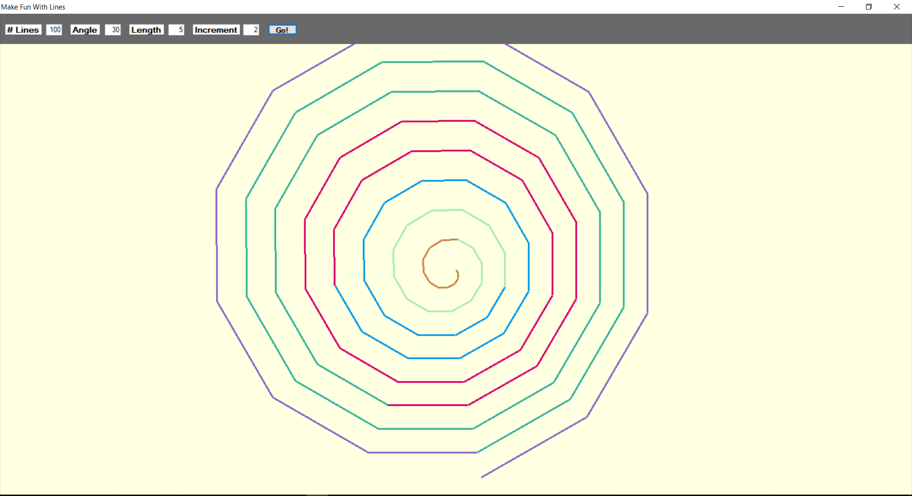

**If Lines = 100, angle = 50, Length = 5, Increment = 2**

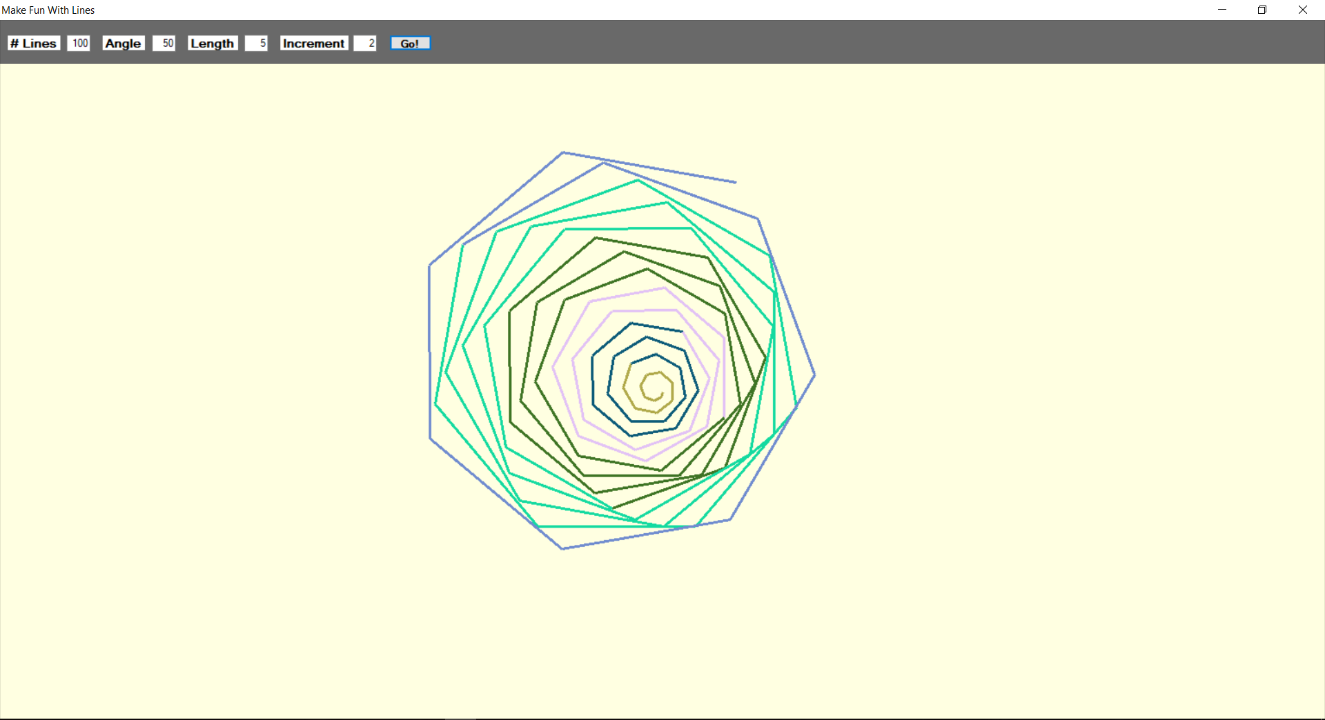

**If Lines = 100, angle = 60, Length = 5, Increment = 3**

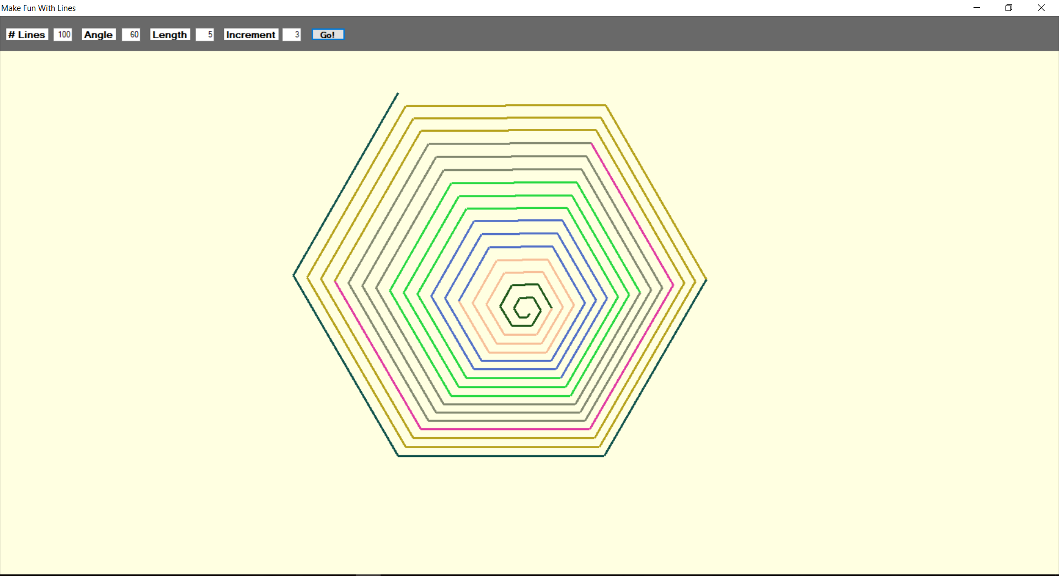

**If Lines = 100, angle = 90, Length = 5, Increment = 5**

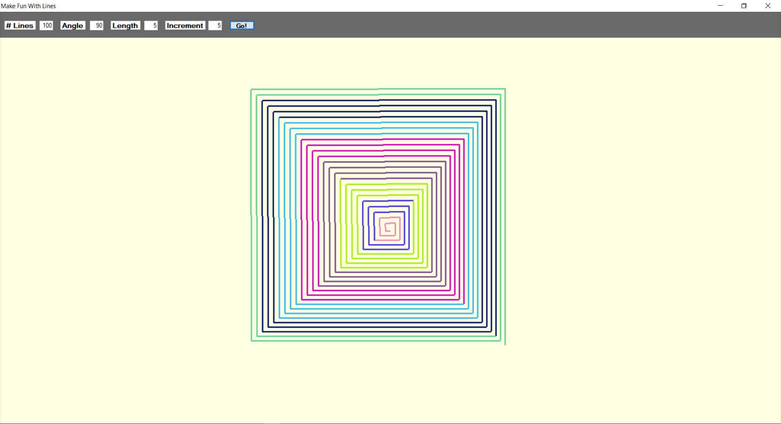

**If Lines = 100, angle = 170, Length = 5, Increment = 6**

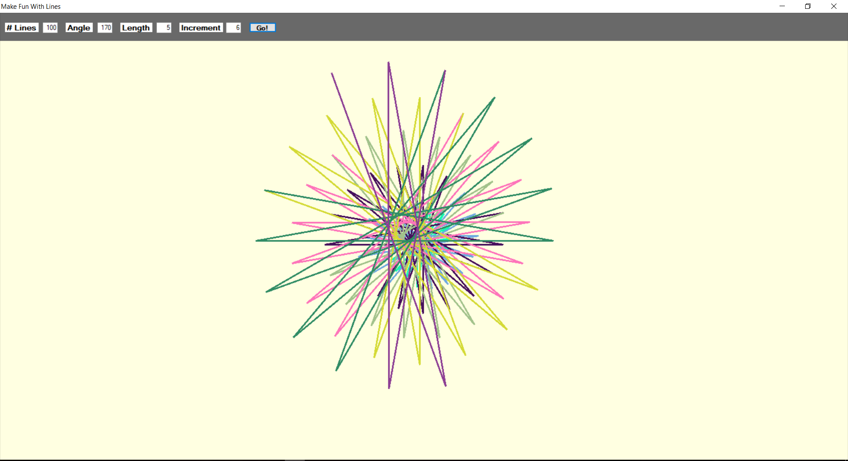

**If Lines = 700, angle = 180, Length = 5, Increment = 8**

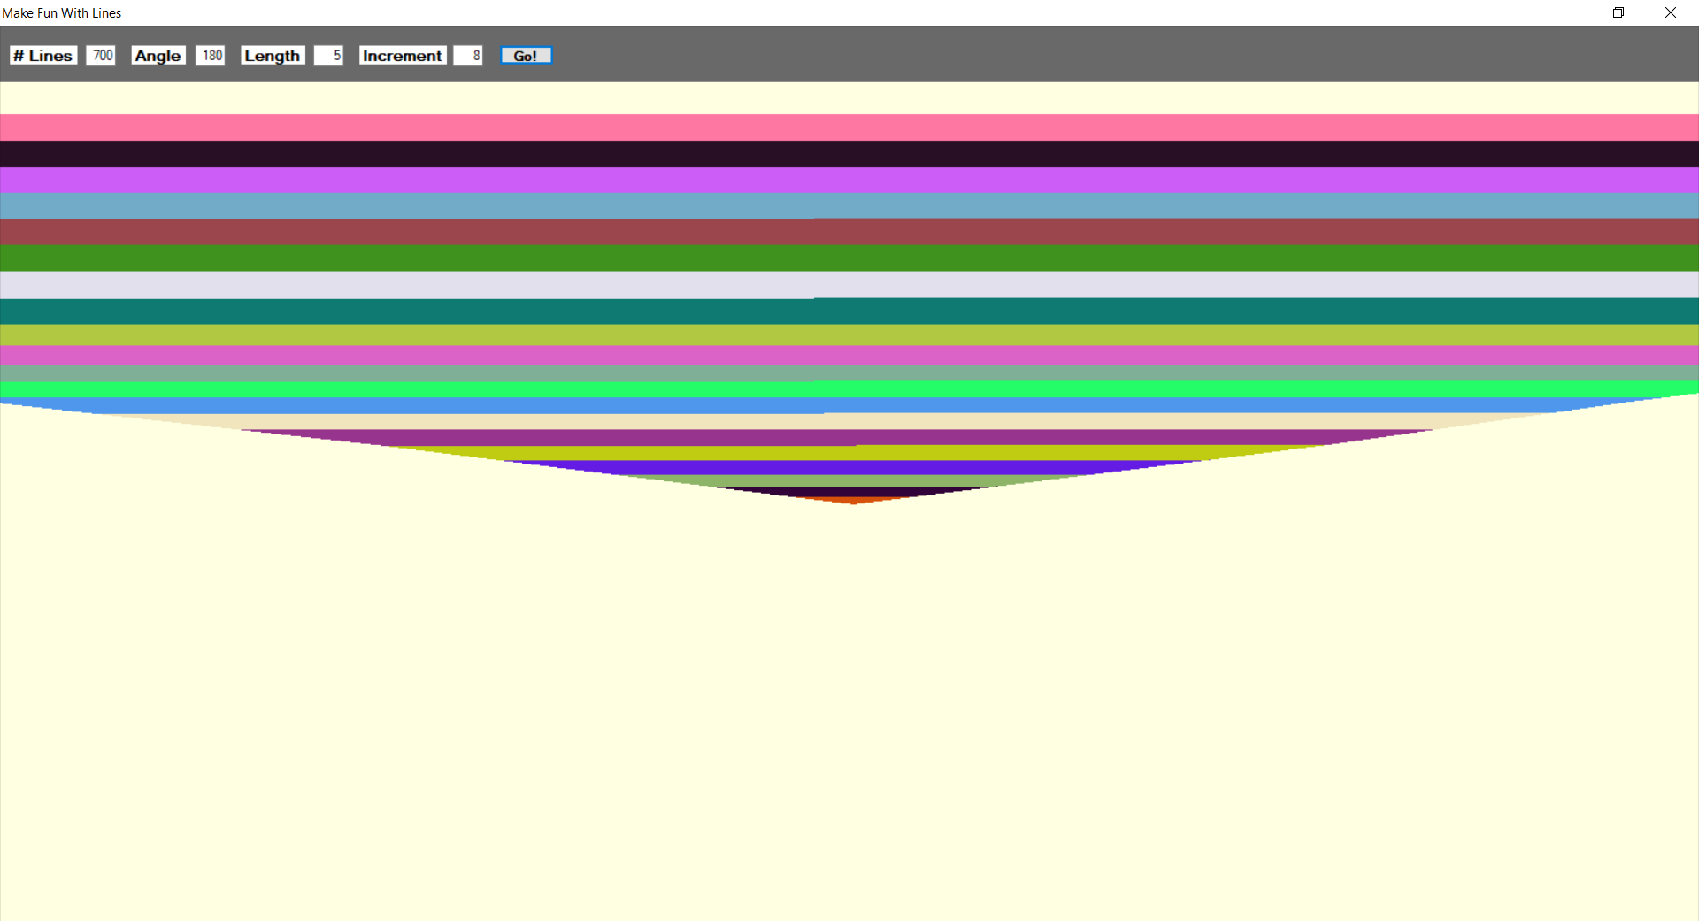

**If Lines = 20000, angle = 190, Length = 5, Increment = 10**

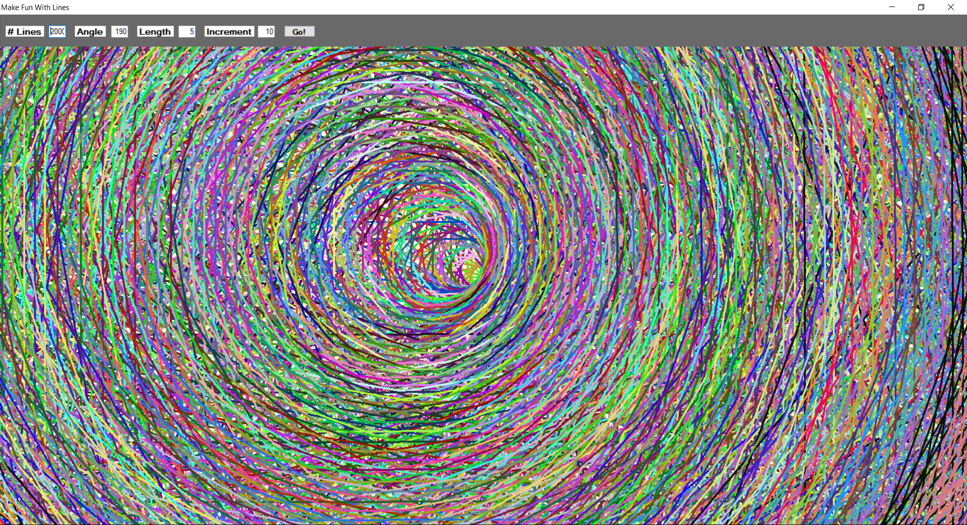

**If Lines = 1000, angle = 200, Length = 5, Increment = 10**

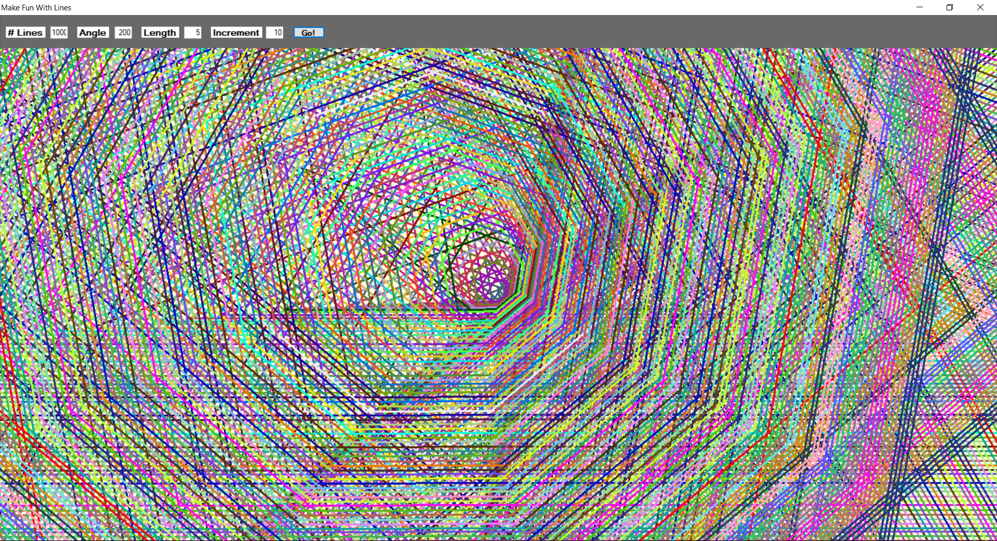

**If Lines = 100, angle = 200, Length = 5, Increment = 7**

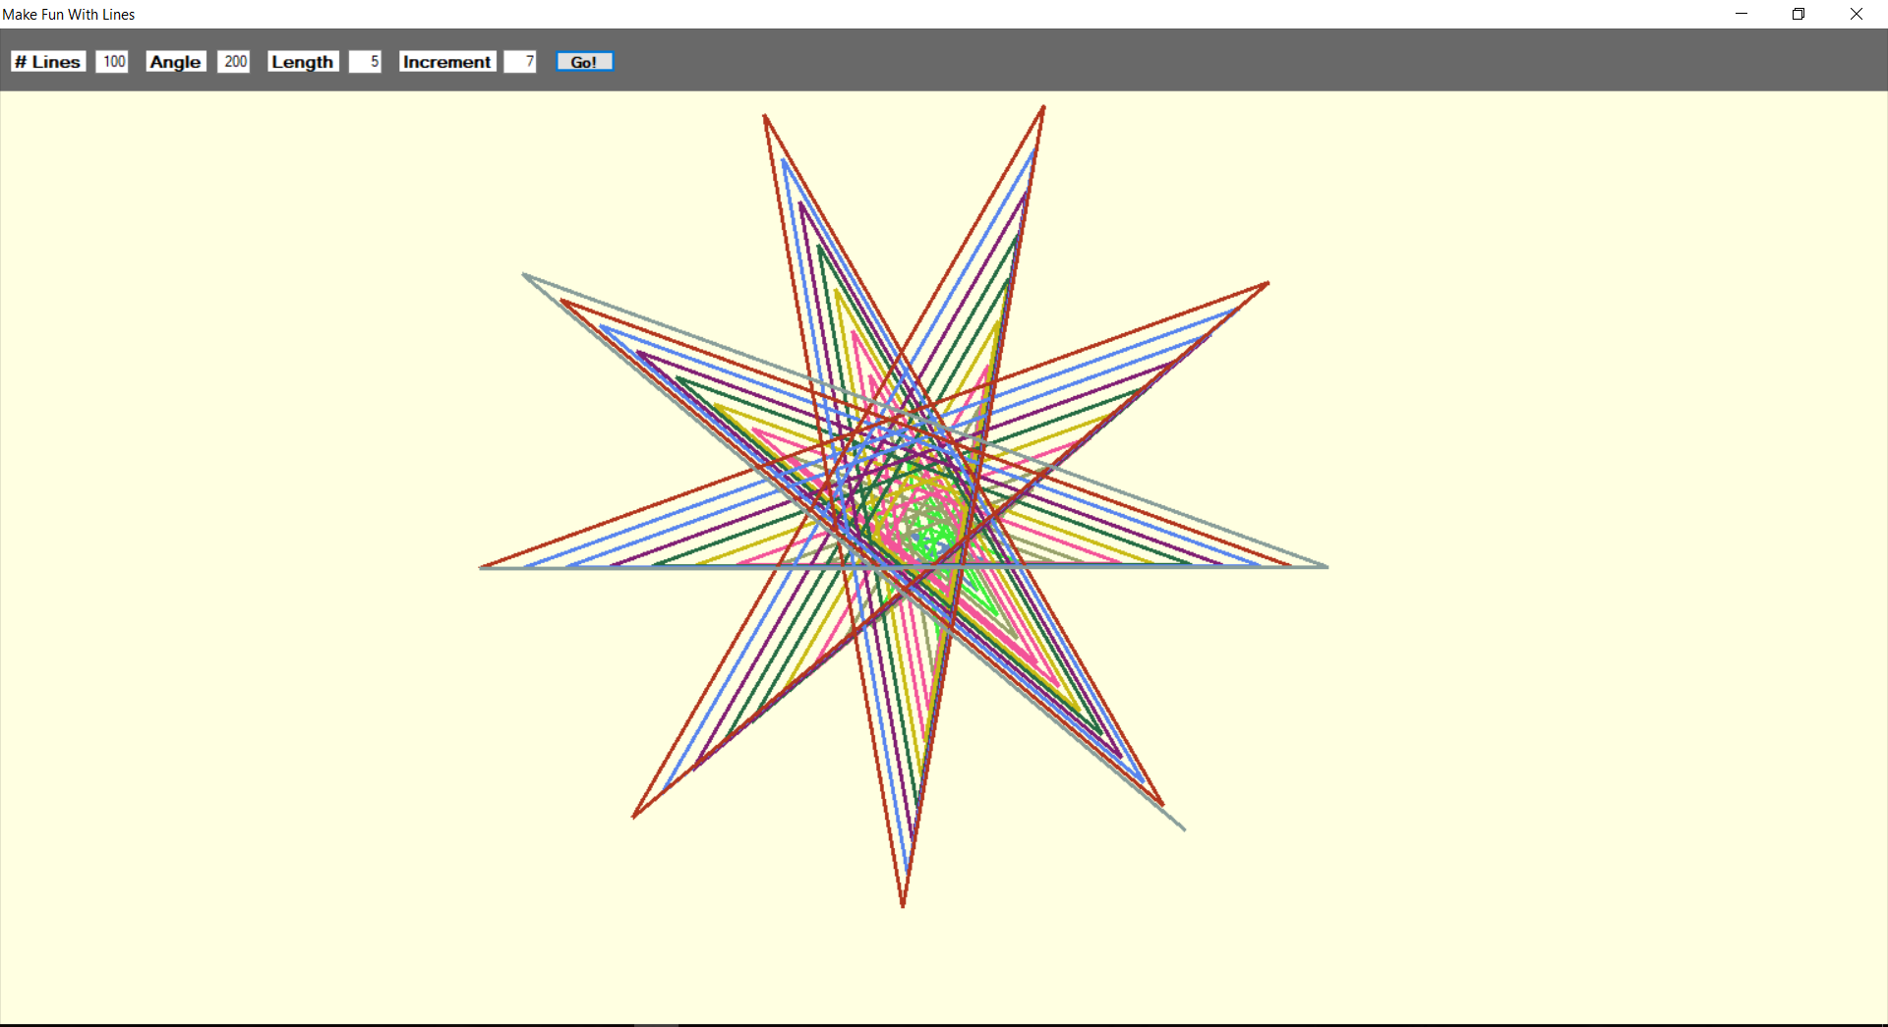

**If Lines = 100, angle = 220, Length = 5, Increment = 7**

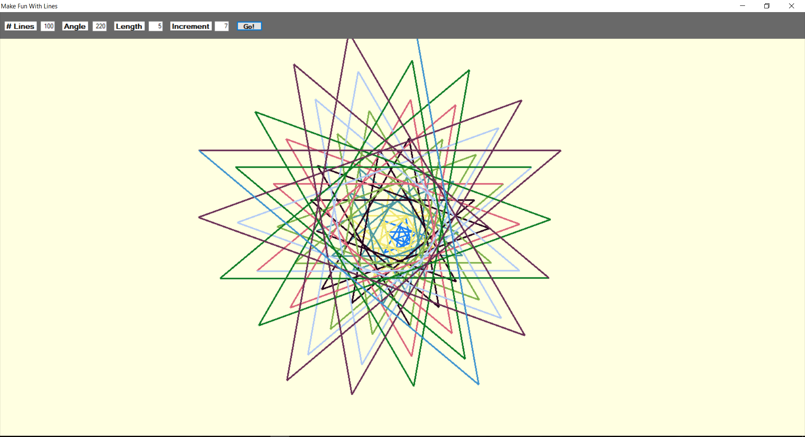

**If Lines = 100, angle = 240, Length = 5, Increment = 6**

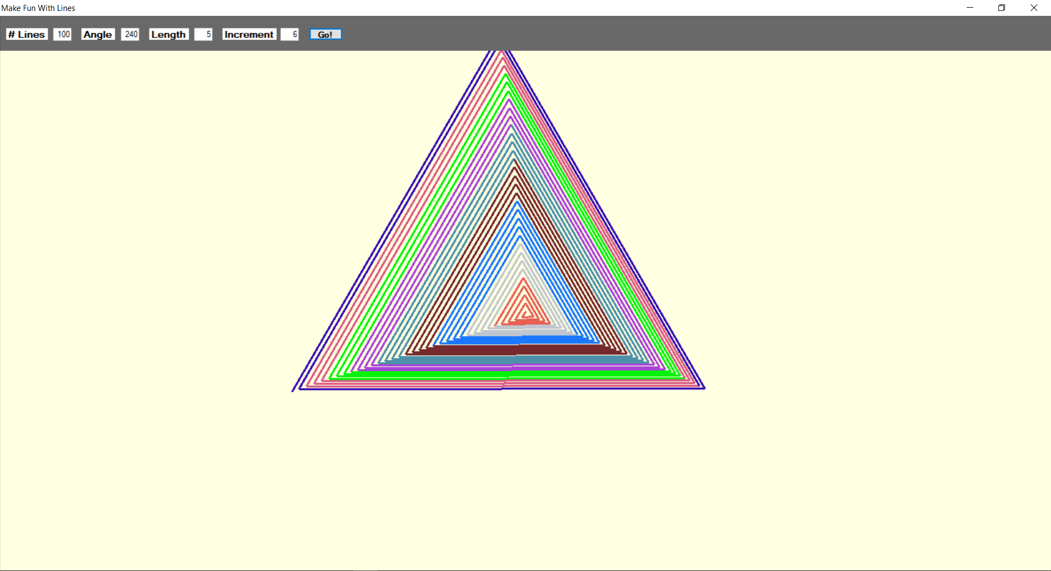

**If Lines = 100, angle = 270, Length = 5, Increment = 6**

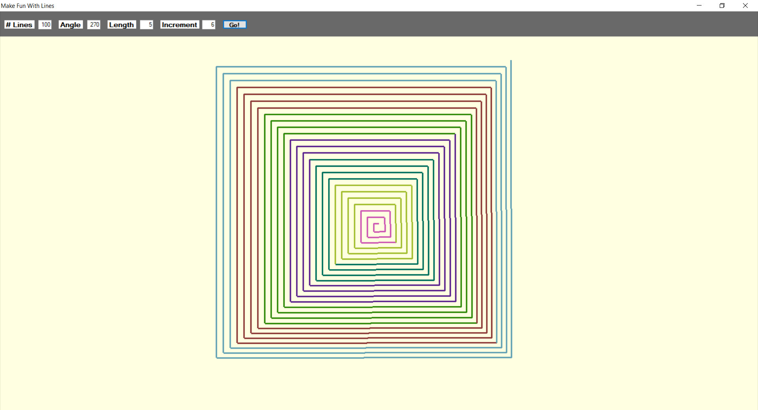

**If Lines = 100, angle = 280, Length = 5, Increment = 5**

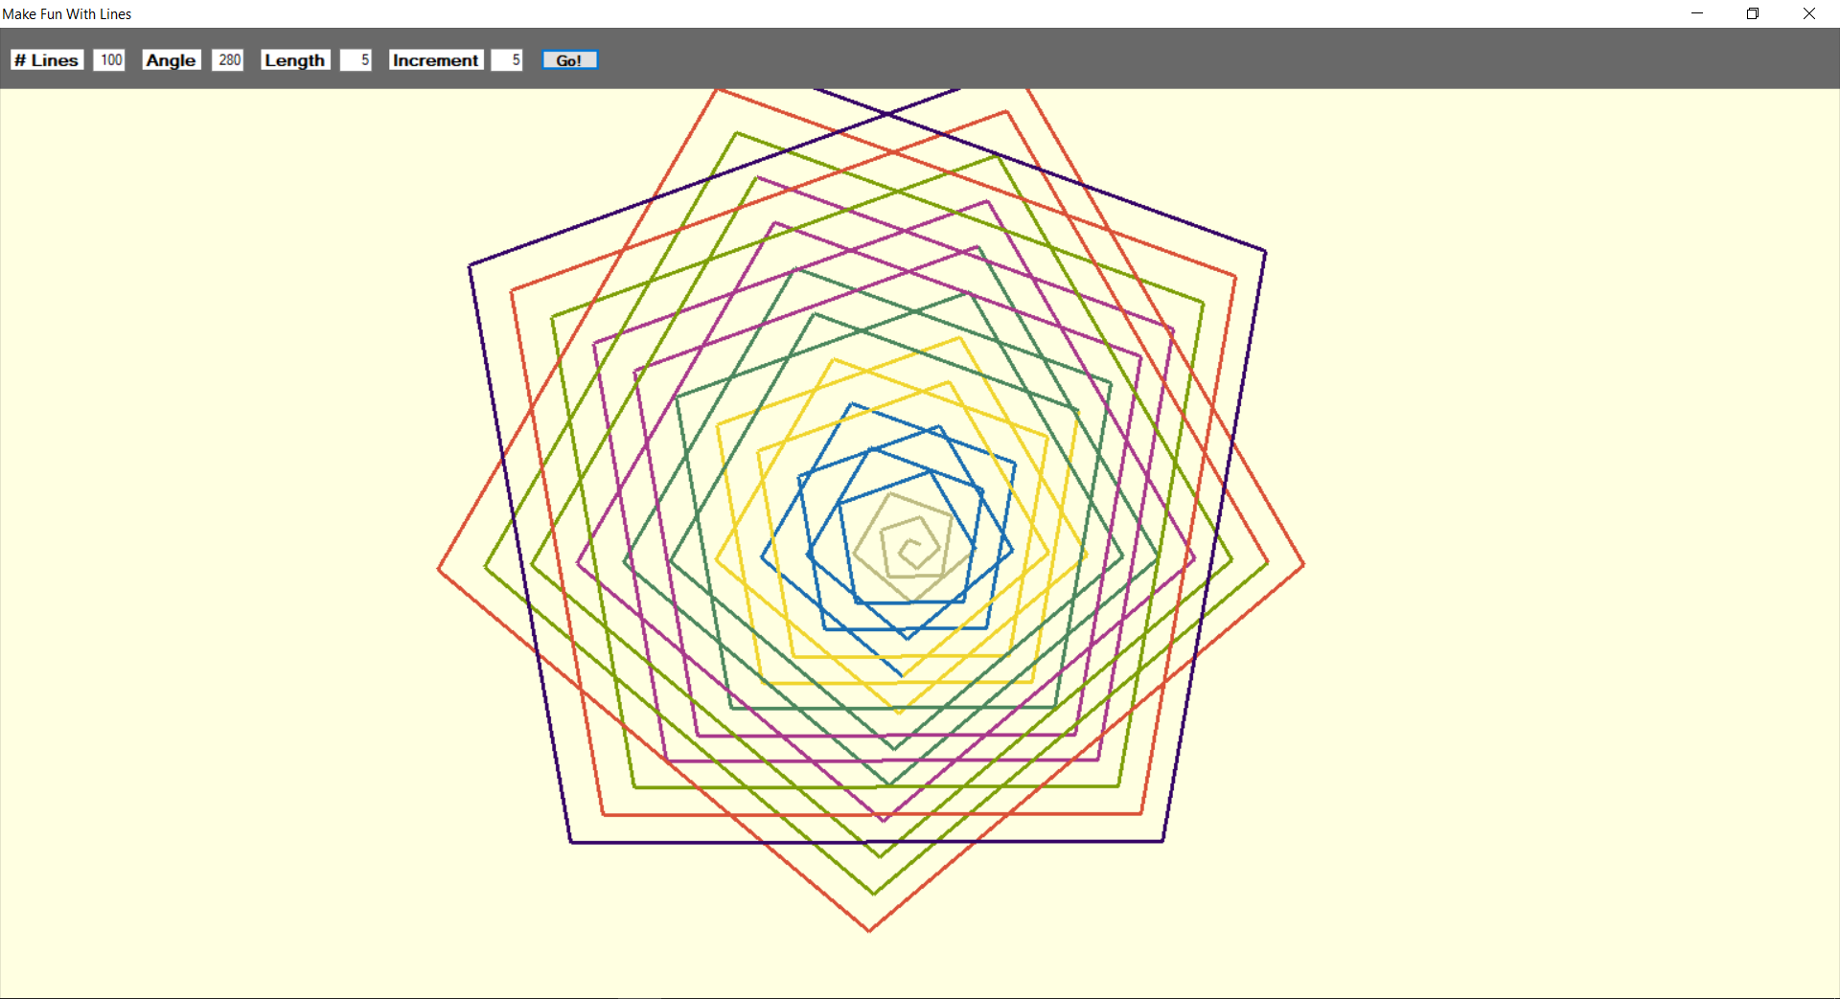

**Code:**

using System;

using System.Collections.Generic;

using System.ComponentModel;

using System.Data;

using System.Drawing;

using System.Linq;

using System.Text;

using System.Threading.Tasks;

using System.Windows.Forms;

namespace Line

{

public partial class Form1 : Form

{

Pen p = new Pen(Color.Green);

Graphics g = null;

static int start_x, start_y;

static int end_x, end_y;

static int my_length = 0;

static int my_increment = 0;

static int my_angle = 0;

static int no_lines = 0;

public Form1()

{

InitializeComponent();

start_x = canvas.Width / 2;

start_y = canvas.Height / 2;

}

private void canvas_Paint(object sender, PaintEventArgs e)

{

no_lines = Int32.Parse(number_of_lines.Text);

p.Width = 3;

my_length = Int32.Parse(length.Text);

g = canvas.CreateGraphics();

for(int i = 0; i < no_lines; i++)

{

drawLine();

}

}

private void drawLine() {

Random randomGen = new Random();

p.Color = Color.FromArgb(randomGen.Next(255), randomGen.Next(255), randomGen.Next(255));

my_angle += Int32.Parse(angle.Text);

my_length += Int32.Parse(increment.Text);

end_x = (int)(start_x + Math.Cos(my_angle * 0.017453292519) * my_length);

end_y = (int)(start_y + Math.Sin(my_angle * 0.017453292519) * my_length);

Point[] points = {

new Point(start_x , start_y),

new Point(end_x , end_y)

};

g.DrawLines(p, points);

start_x = end_x;

start_y = end_y;

}

private void button1_Click(object sender, EventArgs e)

{

my_length = Int32.Parse(length.Text);

my_increment = Int32.Parse(increment.Text);

my_angle = Int32.Parse(angle.Text);

start_x = canvas.Width / 2;

start_y = canvas.Height / 2;

no_lines = Int32.Parse(number_of_lines.Text);

canvas.Refresh();

}

}

}

**Form design:**

